WAD 2021 Poster Contest Rules
- Eligibility. Anyone over 18 years old can enter the contest, except for directors, executives, secretariat staff and officers of the organizers, and their respective spouses, parents, siblings, and children. IAF and ILAC member organizations and their staff are eligible to participate if they are not from those excluded above.

- Submissions from both individuals and teams are accepted.

- Winner/s: Once selected, the winner/s will be required to send their full name, Economy, a short biography and a photo to be used in the promotion of the competition. You will also need to send us additional information to transfer the prize money.

- Organizers. The organizers of this Contest are the International Laboratory Accreditation Cooperation (ILAC) and the International Accreditation Forum (IAF).

- Deadline! Submit your poster until 15 March 2021 (UTC 23:00). Submissions received after this time will not be considered.

- Submission. Send up to three entries to CMC@iaf.nu

- Prizes. The winning team will receive USD 1 500, while second and third places will receive USD 500 each.

- Specifications:
Your entry should illustrate in poster format how Accreditation and accredited conformity assessment services support the implementation of the sustainable development goals (SDGs).

- You can find more information on the World Accreditation Day theme here:
Draft IAF/ILAC Joint Statement
Take Action for the Sustainable Development Goals – United Nations Sustainable Development
United Nations Sustainable Development – 17 Goals to Transform Our World
To download logos and communication material for SDGs: Communications materials – United Nations Sustainable Development
- The posters should feature the following logos and text
1) The logos of the two organizations in the following order:
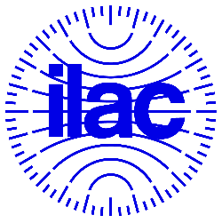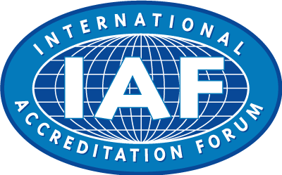
The IAF and ILAC Secretariats will provide the required high resolution IAF and ILAC logos to the selected contestants to insert in the winning designs prior to publication.
2) The following text:
World Accreditation Day
Accreditation: Supporting the implementation of the SDGs
09 June 2021

Poster format
ISO A2 format (420 x 594 mm)
Please note, you must only submit original designs that you have worked on yourself (as an individual or as a team). Use of others’ work will automatically disqualify a submission!
Please send us your designs in .pdf format. If you are submitting more than one design, please send them as separate files.
Selection process: ILAC and IAF will make an initial selection and announce the posters to be put up for the JWGC voting in March 2021.
We will then post the top entries, e.g. the top ten, on a Survey platform to allow ILAC and IAF JWGC members to vote on the best entries.
Design
If your design is selected as the first prize winner, you will be asked to supply for printing:
• A high definition (300 dpi resolution) file of the poster, with a 5 mm bleed on all four sides
• The original files including fonts and graphics
• The text must be editable for economies who will want to reproduce the posters in their national languages
• The files should be editable in InDesign, Photoshop or Illustrator.
Please note: ILAC and IAF will get full rights to the entries(s) you submit. By submitting your entry to this contest, you grant the organizers (jointly and severally) a worldwide, royalty-free, perpetual, non-exclusive right and license to copy, distribute, and display each submitted entry, in any media including posting in an online gallery, publication(s), and various marketing materials, and with right to use, copy, modify, edit, and create derivative works therefrom, and agree to execute documents confirming such right and license at the organizers’ reasonable request. The organizers’ decision is final and no further correspondence will be entered into on announcement of the winners.
By entering the Contest, you hereby represent and warrant that you have read these rules and are fully familiar with their contents.
Questions? Get in touch on CMC@iaf.nu or ilac@nata.com.au

