WAD 2021 Video Contest Rules
- Eligibility. Anyone over 18 years old can enter the contest, except for directors, executives, secretariat staff and officers of the organizers, and their respective spouses, parents, siblings, and children. IAF and ILAC member organizations and their staff are eligible to participate if they are not from those excluded above.

- Submissions from both individuals and teams are accepted.

- Winner/s: Once selected, the winner/s will be required to send their full name, economy, a short biography and a photo to be used in the promotion of the competition. You will also need to send us the necessary information to transfer the prize money.

- Organizers. The organizers of this contest are the International Laboratory Accreditation Cooperation (ILAC) and the International Accreditation Forum (IAF).

- Deadline! Submit your poster until 15 March 2021 (UTC 23:00). Submissions received after this time will not be considered.

- Prizes. The winning team will receive USD 1 500, while second and third places will receive USD 500 each.

- Specifications: Your entry should illustrate in a video format how accreditation and accredited conformity assessment services support the implementation of the Sustainable Development Goals (SDGs).

- You can choose to cover one or many SDGs in your video.

- Your video should include a three-second closing frame displaying the visual identity of ILAC and IAF and the WAD theme (Accreditation: Supporting the implementation of the SDGs). The logos of the two organizations can be found below:
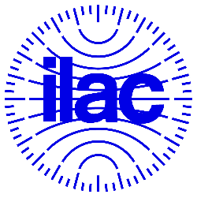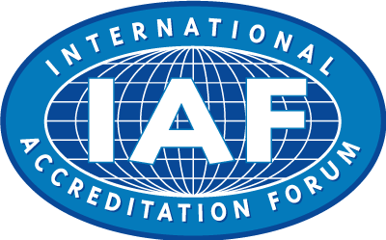
The IAF and ILAC Secretariats will provide the required high resolution IAF and ILAC logos to the selected contestants to insert in the winning designs prior to publication.
- You can find more information on the World Accreditation Day theme here:
- Draft IAF/ILAC Joint Statement
Draft Joint Statement
- About the SDGs:
United Nations Sustainable Development – 17 Goals to Transform Our World
To download logos and communication material for SDGs: Communications materials – United Nations Sustainable Development
For your inspiration:
Videos – United Nations Sustainable Development
https://youtu.be/xVWHuJOmaEk
https://youtu.be/kGcrYkHwE80
3. The following text:
World Accreditation Day
Accreditation: Supporting the implementation of the SDGs
09 June 2021
- Length and format. Your video should be a maximum of 2 minutes long and be the standard YouTube format (16:9 aspect ratio). Videos should either be in English or contain accurate English subtitles.

- Submit your entry. Your video entry should be uploaded to a YouTube account and set to “public”. The video description on YouTube should include:
- Your name or the names of team members.
- A very brief explanation of the SDGs covered in your video.
- A statement along these lines: This is our entry to the World Accreditation Day #WAD2021 competition organized by ILAC.org and IAF.nu.
- An email address where we can contact you.
After uploading your video, send an email to CMC@iaf.nu with the link to your video clearly stating that this is your entry. For example: “Here is my entry to the World Accreditation Day #WAD2021 competition.” Don’t forget to include the link to your video on YouTube and the hashtag #WAD2021.

The same team (or any individual from a team) can submit up to three videos to be considered as separate entries. Once we receive your entry, we will add it to a playlist on our YouTube channel or a social media album.

Please note, you must only submit original designs that you have worked on yourself (as an individual or as a team). Use of others’ work will automatically disqualify a submission!
- Data protection. Anything you choose to put on Twitter/YouTube is subject to their respective privacy policies. We may retweet or re-share your posts within their respective platforms. We may also post the top entries without your name on our Youtube channel and survey platforms for others to vote on. If you are selected as a winner, we will ask for your full name(s), economy(ies) of origin, (a) short biography(ies) and a photo of you/your team so that we can talk about the winning entries in our newsletters, website, social media accounts, and at any award ceremony (if applicable). You may be asked to sign a video release form before you may be announced as the winner.
Economies where Twitter/YouTube is blocked: An exception is made for residents of economies where Twitter/YouTube is blocked. You can submit your video as a compressed MPEG file of less than 4MB to CMC@iaf.nu.
Selection process: ILAC and IAF will make an initial selection and announce the videos to be put up for Joint Working Group Communications (JWGC) voting in March 2021.
We will then post the top entries, e.g. the top ten, on our Youtube channel and a survey platform to allow ILAC and IAF JWGC members to vote on the best entries.
Please note: ILAC and IAF will get full rights to the entries(s) you submit. By submitting your entry to this contest, you grant the organizers (jointly and severally) a worldwide, royalty-free, perpetual, non-exclusive right and license to copy, distribute, and display each submitted entry, in any media including posting in an online gallery, publication(s), and various marketing materials, and with right to use, copy, modify, edit, and create derivative works therefrom, and agree to execute documents confirming such right and license at the organizers’ reasonable request. The organizers’ decision is final and no further correspondence will be entered into on announcement of the winners.
By entering the contest, you hereby represent and warrant that you have read these rules and are fully familiar with their contents.
Questions? Get in touch at CMC@iaf.nu or ilac@nata.com.au

